APPLICATION FOR ADMISSION TO THE LGSETA/NMBM PRIORITY AREAS EMPLOYEE BURSARY POLICY

The completed form together with all supporting documentation must be submitted to the Executive Director: Corporate Services, Skills Development and Employment Equity Sub-directorate, Starport Building (15th Floor), Govan Mbeki Avenue, Gqeberha.

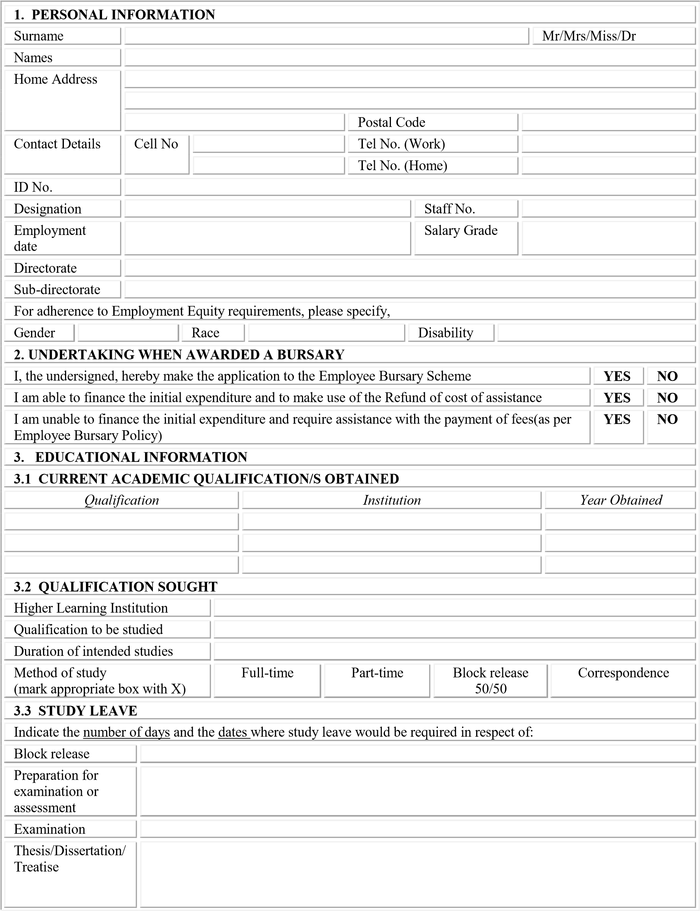

I undertake to abide by the conditions of the Nelson Mandela Bay Metropolitan Municipality’s Employee Bursary Policy and the decision(s) of the municipal Employee Bursary Committee and to enter into an agreement with the MUNICIPALITY to receive the bursary.
SIGNED AT-------------------------------- ON THE ---------------------------- DAY OF -------------------------------------------

Signature of Applicant: ------------------------------------
REQUIRED SUPPORTING DOCUMENTS: TICK IF ATTACHED
Certificate Identified Document
Certified Grade 12 Certificate
Certified Grade 12 Statement of Results
Certified Tertiary Qualification(s) obtained
Certified Academic Record of previous qualification (currently studying qualification applying for)
Course outline for duration of qualification
Course timetable for duration of qualification
Quotation from Institution for qualification applying for
Proof of acceptance to Institution (Acceptance Letter)
- ALL CERTIFIED DOCUMENTS TO NOT BE OLDER THAN SIX (6) MONTHS ON THE DATE OF SUBMISSION.
- ALL APPLICATIONS MUST BE SUBMITTED BEFORE OR ON THE CLOSING DATE OF 23rd JANUARY 2024.
- LATE APPLICATION FORMS SUBMITED WILL NOT BE ACCEPTED OR CONSIDERED
- APPLICATIONS TO BE SUBMITTED AT 15TH FLOOR, STARPORT BUILDING, GOVEN MBEKI AVENUE.
- APPLICATION FROMS NOT ACCOMPNANIED BY THE REQUIRED SUPPORTING DOCUMENTS STATED ABOVE WILL NOT BE ACCEPLATABLE.
4. SUPERVISOR’S RECOMMENDATION
THE APPLICATION IS SUPPORTED/DECLINED, FOR THE FOLLOWING REASON(S):

…………………………………………………………………………………………………………………………… ……………………………………………………………………………………………………………………………
……………………………………………………………………………………………………………………………

.…………………………………………….. ……….………………………..
SIGNATURE: SUPERVISOR SUB- DIRECTORATE

…………………………………………… …………………………………
PRINT FULL NAME AND SURNAME DATE
5. DIRECTOR’S RECOMMENDATION
THE APPLICATION IS SUPPORTED/DECLINED, FOR THE FOLLOWING REASON(S):

…………………………………………………………………………………………………………………………… ……………………………………………………………………………………………………………………………
……………………………………………………………………………………………………………………………

.…………………………………………….. ……….………………………..
SIGNATURE: DIRECTOR SUB-DIRECTORATE

…………………………………………… …………………………………
PRINT FULL NAME AND SURNAME DATE

6. EXECUTIVE DIRECTOR’S RECOMMENDATION

THE APPLICATION IS SUPPORTED/DECLINED, FOR THE FOLLOWING REASON(S):

……………………………………………………………………………………………………………………………
…………………………………………………………………………………………………………………………… ……………………………………………………………………………………………………………………………

THIS SECTION IS FOR SKILLS DEVELOPMENT & EMPLOYMENT EQUITY (KINDLY LEAVE BLANK)

7. COMMENTS BY THE EXUCUTIVE DIRECTOR: CORPORATE SERVICES
APPROVED /NOT APPROVED
………………………………………………………………………………………………………………………………………………………………………………………………………………………………………………………………………………………………………………………………………………………………………………………………………………………………………………

.…………………………………………….. ……….………………………..
SIGNATURE: EXECUTIVE DIRECTOR DIRECTORATE

…………………………………………… …………………………………
PRINT FULL NAME AND SURNAME DATE
KINDLY NOTE THAT THE NMBM WILL NOT BE LIABLE FOR ANY TRANSPORTATION, ACCOMODATION, AND MEAL COSTS.

